**Integrated Photonics for Sensing, Interconnects and Computing with Artificial Intelligence and Machine Learning Applications**

Ray T. Chen

Integrated Photonics Research Lab

Electrical and Computer Engineering

University of Texas, Austin

<http://www.mrc.utexas.edu/people/faculty/ray-chen>

**Abstract**

The advancement of sensing, interconnects and computing in the last one hundred years is mainly from the R&D works on electrons and photons, which carry drastically different characteristics defining different technology roadmaps. Due to the saturation of the Moore’s law, the advantages of photon-based devices provide solutions with the unprecedented performance. In this talk, we will present the integrated photonic devices covering near and mid-IR wavelengths for spectroscopy, biosensing and SERS. Mid-IR Lidar Chip centered at 4.6 micron will also presented. Silicon photonics for both digital and analog computing will be introduced with low latency, high bandwidth and multi-wavelength operations for AI and ML applications.

**The speaker**

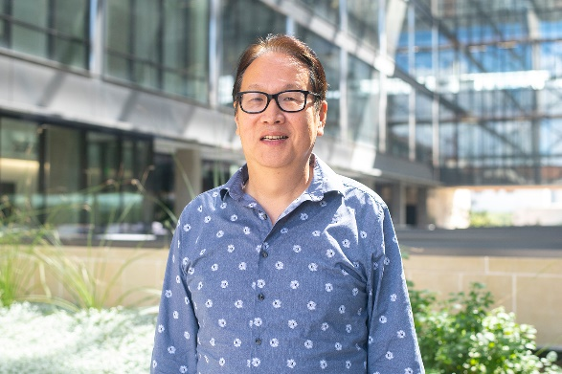Ray T. Chen Graduated from TsingHua University in Taiwan with a B.S. degree in Physics in 1980. He received his PhD degree in EE from the University of California in 1988. He is currently a senior Endowed Chair Professor at The University of Texas Austin. His research work has been awarded over 150 research grants and contracts from such sponsors as Army, Navy, Space-Force, Air-Force, DARPA, MDA, NSA, NSF, DOE, EPA, NIST, NIH, NASA, Texas State, and private industry.

He was the recipient of the 1987 University of California Regent’s Dissertation Fellowship and the 1999 UT Engineering Foundation Faculty Award, for his contributions in research, teaching and services. He received the honorary citizenship award in 2003 from the Austin city council for his contribution in community service. He was also the recipient of the 2008 IEEE Teaching Award, and the 2010 IEEE HKN Loudest Professor Award. 2013 NASA Certified Technical Achievement Award for contribution on moon surveillance conformable phased array antenna. His group received numerous best paper awards from IEEE, SPIE and Optica. Chen’s group at UT Austin has reported its research findings in more than 1,000 publications carrying an H-Index of 66, including over 100 invited papers and 82 patents. Chen is a Fellow of the National Academy of Inventors, IEEE, Optica, and SPIE. Chen has supervised 41 postdocs and graduated 59 PhD students from his group.